**HOW THE CAR MOVES (FORWARD, RIGHT, LEFT)**

The movement of the car is controlled by adjusting the motor pin signals based on yaw readings from the MPU6050 sensor.

There are three main functions to move the car:

1. 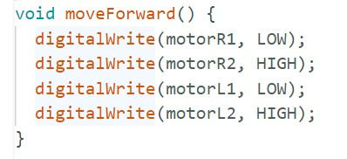Forward Movement:

* The function moveForward() sets the right motor (motorR1 and motorR2) and the left motor (motorL1 and motorL2) to rotate forward.
* This makes both wheels rotate in the forward direction, causing the car to move straight ahead

1. Right Turn:

* A computer code with text

  Description automatically generatedThe function moveRight() rotates the right motor backward (motorR1, HIGH; motorR2, LOW;) and the left motor forward (motorL1, LOW; motorL2, HIGH;).
* •This combination causes the car to pivot to the right as the left motor pushes forward while the right motor moves backward.

1. 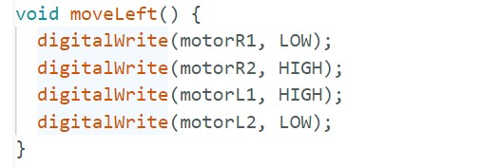Left Turn:

* The function moveLeft() rotates the left motor backward (motorL1, HIGH; motorL2, LOW;) and the right motor forward (motorR1, LOW; motorR2, HIGH;).
* This causes the car to pivot to the left.